|  |  |
| --- | --- |
| Date | 2 Nov 2022 |
| Team ID | PNT2022TMID27677 |
| Project Name | Smart Fashion Recommender Application |
| Team members | B.Nandita  Faustina Philomena Fernado  G.V.Leaaka shree  S.Aarthi |

Sendgrid Open Page:

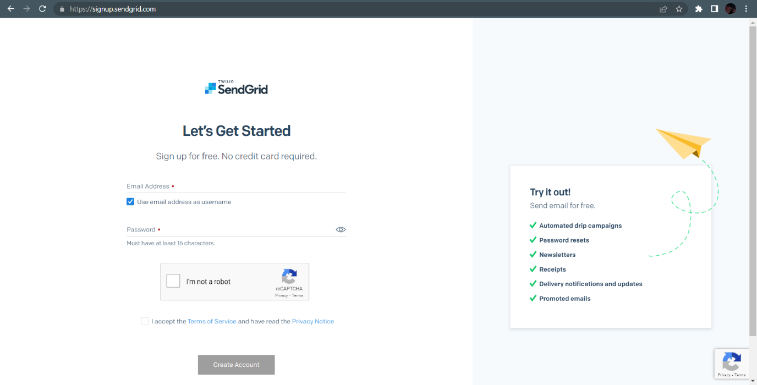Sendgrid login Page:

Sendgrid successfully created:

